产品封面图
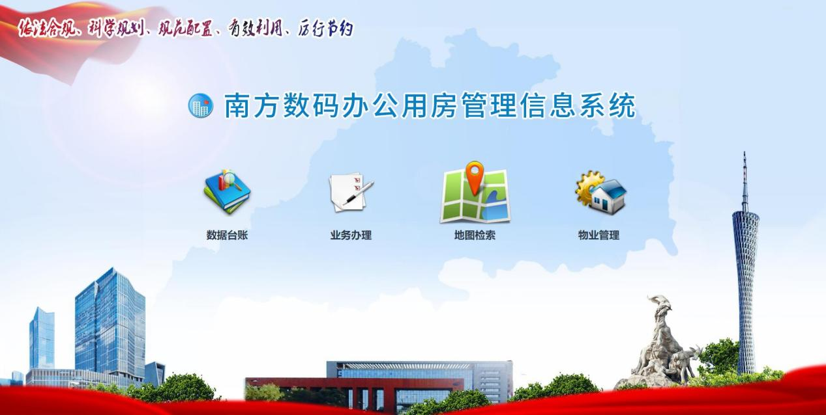

产品中文名称
南方数码办公用房管理信息系统

产品英文名
Office space management information system of South Digital Technology CO., LTD.

产品标签
全生命周期管理、VR虚拟现实、GI

产品品牌
南方数码

视频：另附

产品中文简介
本办公用房管理信息系统严格贯彻国家《党政机关办公用房管理办法》关于加强办公用房集中统一管理，健全办公用房档案、建立信息统计报告和巡检考核制度的有关要求，并结合实际办公用房管理工作中业务需求，开发建设而成，系统主要分为可视化“数据台账”、全流程“业务办理”、全方位“地图检索”、标准化“物业管理”四大功能模块，重点创新设计实现“房屋全景影像”、“智能平层图纸”、“辅助决策支持”等特色功能。运用GIS、平面图纸、BIM虚拟模型、VR虚拟现实全景影像等技术，实现办公用房由文字管理到影像管理的实景体验，不仅达到“账账相符、账实相符、账证相符”，实现了办公用房的全生命周期管理，在办公用房管理工作中发挥了重要作用。
系统以“数据统一、业务协同”模式建设，达到管理独立，数据互联互通，实现了业务管理一张网，解决数据信息孤岛、管理困难等诸多问题。

英文简介
The office space management information system is developed and constructed in strict accordance with the relevant requirements of the national "measures for the management of office space of Party and government organs" on strengthening the centralized and unified management of office space, improving office space archives, establishing information statistical report and inspection and assessment system, and combining with the actual business needs of office space management. The system is mainly divided into four functional modules: visualization of data account, comprehensive service, comprehensive map retrieval, and standardized property management. It focuses on the innovative design and realization of "house panoramic image", "intelligent leveling drawing", "auxiliary decision support" and other characteristic functions.This system achieves the real scene experience of office space from text management to image management by using GIS, plane drawings, BIM virtual model, vr virtual reality panoramic image and other technologies,which not only achieves the account matching,and the whole life cycle management of office building. It plays an important role in office space management.
The system is built in the mode of "data unification and business collaboration", which achieves independent management and data interconnection, and solves many problems such as data information island and management difficulty.

