数据中心 IDC

中国通信服务致力于建设最绿色数据中心，全面助力国家碳中和、碳达峰的政策目标，我们能在全生命周期提供一揽子解决方案。截至目前，我们服务过客户超3000多家，遍布全国各行各业，参建的数据中心总机架数超100万个，取得了多项全国之最。

China Comservice is committed to building the environment-friendly data center in the world, and doing its best to contribute to the national policy goal of carbon neutral and carbon peak. We could provide a package of solutions throughout the whole life cycle. Up to now, we have served more than 3,000 customers throughout all walks of life around the country, participated in the construction of more than 1 million data center total frame, a number of the country's most. Moreover, we have participated in the construction of more than 1 million data centers, which has achieved many of the highest numbers in China.

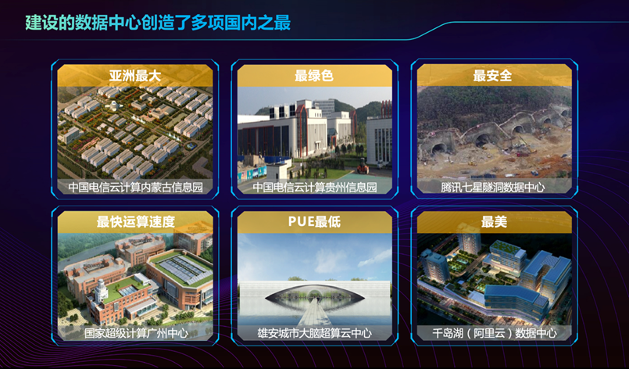

中通服提供数据中心全生命周期的一揽子解决方案，从咨询、设计、实施、交付到运行、维护各个阶段，为客户提供定制化、模块化、一体化的无忧服务。

Our enterprise offers a package of solutions across the data center lifecycle, from consulting, design, implementation, delivery to operation, maintenance stages, to provide customers with customized, modular, integrated worry-free services.
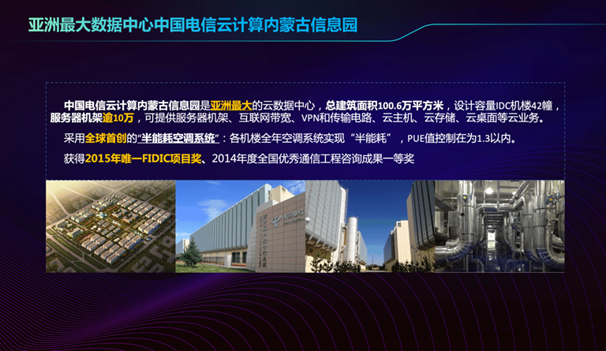

中国电信云计算内蒙古信息园，是全亚洲最大的数据中心，总建筑面积100.6万平方米，服务器机架数逾10万个

采用的全球首创的半能耗空调系统，风侧自然冷却，整体PUE可以控制在1.3以内

获得了2015年唯一FIDIC项目奖

Inner Mongolia Information Park of China Telecom Cloud Computing is the largest data center in Asia, with a total construction area of 1.006 million square meters and more than 100,000 server racks.
There, we adopt the world's first semi-energy air-conditioning system, the wind side of the natural cooling, the overall PUE can be controlled within 1.3
Won the only FIDIC project award in 2015

国内最绿色的数据中心，中国电信云计算贵州信息园。
充分利用当地的自然环境和气候条件，实现全新风空调免费制冷，全年实现200天以上的免费制冷。
同时，项目三面环山，整体建筑风格与周围环境协调融合，被称为最绿色的数据中心。
The most eco-friendly data center in China, China Telecom Cloud Computing Guizhou Information Park.
Make full use of the local natural environment and climate conditions, to achieve free refrigeration of all fresh air conditioning, to achieve more than 200 days of free refrigeration throughout the year.
At the same time, the project is surrounded by mountains on three sides, and the overall architectural style is in harmony with the surrounding environment, known as the most environmentally friendly data center.

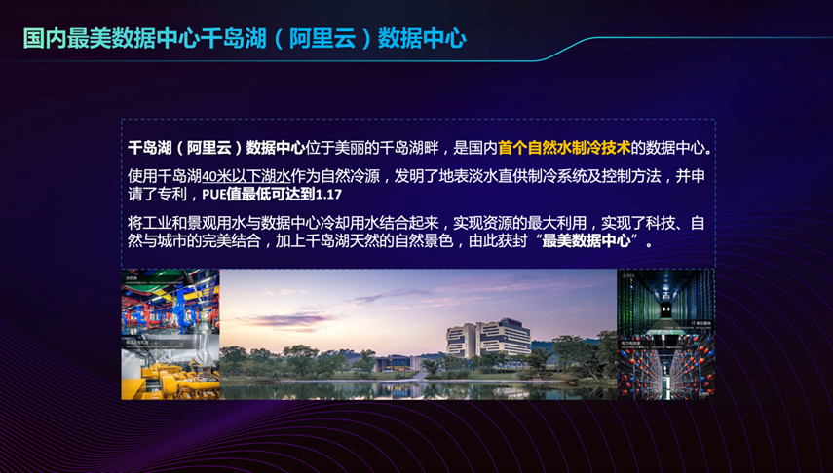

国内最美的数据中心，千岛湖（阿里云）数据中心
将工业和景观用水与数据中心冷却用水结合起来，实现资源的最大利用，实现了科技、自然与城市的完美结合，加上千岛湖天然的自然景色，被称为“最美数据中心”。
The most beautiful data center in China, Qiandao Lake (Ali cloud) data center.
It combines industrial and landscape water with data center cooling water to maximize the use of resources, and achieve the perfect combination of science and technology, nature and city. Because of this feature and the natural scenery of Qiandao Lake, it is called "the most beautiful data center".

